Practical 1
1. whoami

displays the user name

2. pwd

present working directory
3. ls

4. ls -r
5. ls-q
6. history
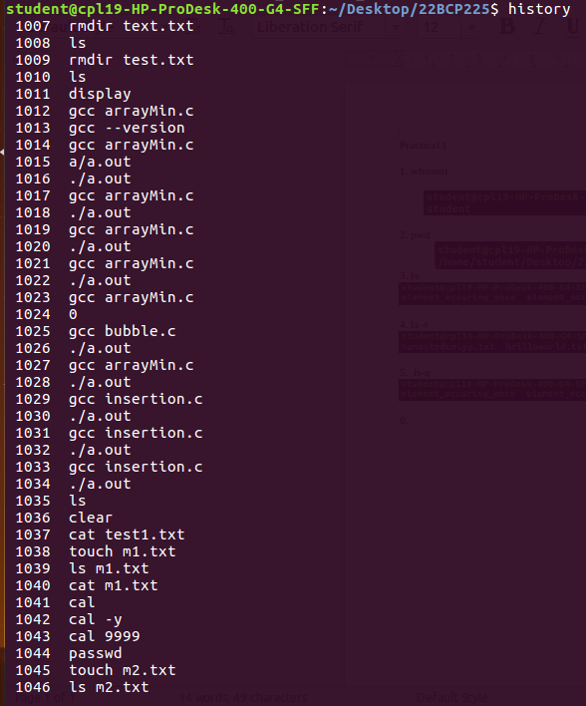
7. clear
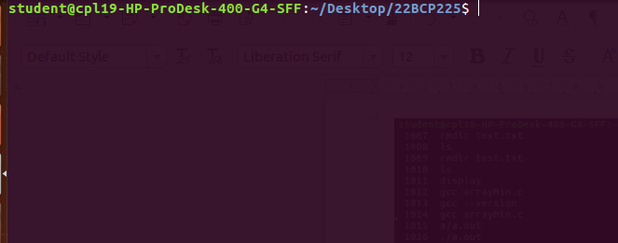
8. echo
9. chmod
10. wc
11. touch
12. rm
13. mkdir
14. rmdir
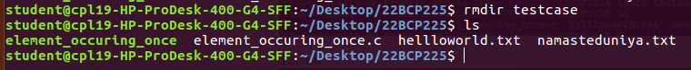
15. mv

16. cd
17. cmp
18. cat
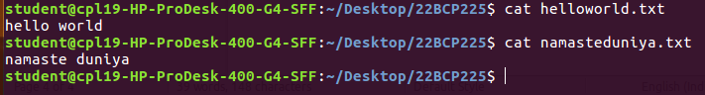
19. comm
20. date
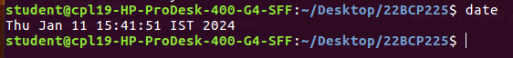
21. cal
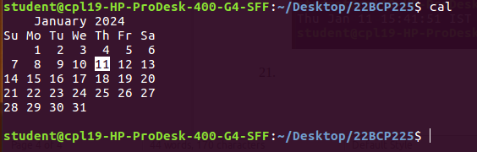
22. passwd
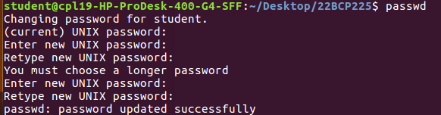
23. grep
24. free
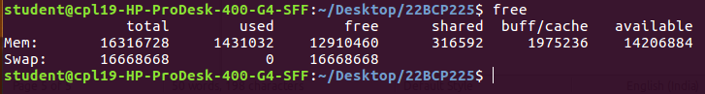
25. uname
26. groups
